Project Report:
Design and Optimization of a 5.9 GHz Two-Element MIMO Microstrip Patch Antenna for V2X Communication Using CST Studio Suite
By:
Suyash Shah



ELECTRONICS AND COMMUNICATION ENGINEERING DEPARTMENT (ECED)
THAPAR INSTITUTE OF ENGINEERING AND TECHNOLOGY
(DEEMED TO BE UNIVERSITY)
PATIALA, PUNJAB (147004)

Abstract

Vehicle-to-Everything (V2X) communication is a key technology for enabling intelligent transportation systems, autonomous driving, and advanced road safety applications. Reliable wireless communication in V2X networks requires compact, efficient, and high-isolation antenna systems capable of supporting multiple data streams. This project presents the design and optimization of a two-element Multiple-Input Multiple-Output (MIMO) microstrip patch antenna operating at 5.9 GHz for V2X communication applications using CST Studio Suite.

The proposed antenna consists of two rectangular microstrip patch elements fabricated on an FR-4 substrate with a thickness of 1.6 mm. A parametric optimization process was performed to determine the optimal spacing between antenna elements and to evaluate the impact of design modifications on antenna performance. Various antenna characteristics including S-parameters, Voltage Standing Wave Ratio (VSWR), radiation efficiency, total efficiency, Envelope Correlation Coefficient (ECC), Diversity Gain (DG), surface current distribution, and radiation patterns were analyzed.

Simulation results demonstrate excellent impedance matching with a return loss better than -50 dB near the operating frequency. The antenna exhibits very low mutual coupling, high isolation between elements, low ECC in the order of 10⁻⁵, and a diversity gain close to 10 dB, indicating strong MIMO performance. The optimized design also achieves satisfactory radiation characteristics and directivity suitable for V2X communication systems. The proposed antenna structure provides a compact and effective solution for next-generation vehicular communication applications.

1 Introduction

1.1 Background

The increasing demand for intelligent transportation systems has accelerated the development of advanced wireless communication technologies capable of supporting real-time data exchange among vehicles and infrastructure. Vehicle-to-Everything (V2X) communication enables vehicles to communicate with other vehicles, roadside units, pedestrians, and network infrastructure to improve traffic efficiency, reduce accidents, and enhance driving safety. To support these applications, reliable wireless communication systems operating in the 5.9 GHz band are widely employed.

Antennas play a crucial role in determining the performance of wireless communication systems. Among the various antenna types, microstrip patch antennas are widely used because of their low profile, lightweight structure, ease of fabrication, low manufacturing cost, and compatibility with printed circuit board technology. However, conventional single-element antennas often suffer from limited channel capacity and reduced reliability in multipath environments.

1.2 MIMO Technology

Multiple-Input Multiple-Output (MIMO) technology improves communication performance by employing multiple transmitting and receiving antenna elements. MIMO systems increase channel capacity, improve signal reliability, and reduce the effects of fading and interference. For vehicular communication systems where reliable data transmission is critical, MIMO antennas have become an essential component.

One of the major challenges in MIMO antenna design is reducing mutual coupling between antenna elements. High mutual coupling can degrade antenna efficiency, increase correlation between ports, and negatively affect overall system performance. Therefore, antenna element spacing and isolation enhancement techniques must be carefully optimized.

1.3 Problem Statement

Designing a compact MIMO antenna suitable for V2X applications requires achieving good impedance matching, low mutual coupling, high isolation, low envelope correlation coefficient, and acceptable radiation characteristics within the limited available space. Achieving all these requirements simultaneously presents a significant design challenge.

1.4 Objectives of the Project

The main objectives of this project are:

• To design a two-element microstrip patch MIMO antenna operating at 5.9 GHz.

• To model and simulate the antenna using CST Studio Suite.

• To optimize antenna dimensions and element spacing through parametric analysis.

• To investigate the effect of spacing on isolation and antenna performance.

• To evaluate key performance parameters including S-parameters, VSWR, radiation efficiency, total efficiency, ECC, diversity gain, and radiation patterns.

• To develop a compact antenna structure suitable for V2X communication applications.

1.5 Scope of the Project

This project focuses on the simulation, design, and optimization of a two-element MIMO microstrip patch antenna for operation in the 5.9 GHz V2X communication band. The antenna is analyzed using CST Studio Suite, and its performance is evaluated through various electromagnetic parameters. The study is limited to simulation-based analysis and does not include physical fabrication or experimental measurements.

2 Literature Review

2.1 V2X Communication Systems

Vehicle-to-Everything (V2X) communication is an advanced wireless communication technology that enables information exchange among vehicles, roadside infrastructure, pedestrians, and communication networks. The primary objective of V2X systems is to improve road safety, traffic efficiency, and driving comfort. Modern intelligent transportation systems rely heavily on V2X communication for collision avoidance, traffic management, autonomous driving assistance, and emergency response services. The 5.9 GHz frequency band is widely allocated for V2X applications due to its ability to support low-latency and high-reliability communication. As the number of connected vehicles continues to increase, efficient antenna systems become essential for maintaining reliable communication links in dynamic vehicular environments.

2.2 MIMO Antenna Design Techniques

Multiple-Input Multiple-Output (MIMO) technology has become a key component of modern wireless communication systems. MIMO antennas employ multiple radiating elements to increase channel capacity, improve spectral efficiency, and enhance communication reliability. Various MIMO antenna configurations have been proposed in literature, including linear arrays, planar arrays, orthogonal element arrangements, and polarization diversity techniques. The performance of a MIMO antenna is commonly evaluated using parameters such as isolation, Envelope Correlation Coefficient (ECC), Diversity Gain (DG), and radiation efficiency. Effective MIMO antenna design requires careful optimization of element placement, feeding mechanisms, and isolation enhancement techniques to achieve low correlation and high diversity performance.

2.3 Mutual Coupling Reduction Methods

Mutual coupling refers to the unwanted electromagnetic interaction between closely spaced antenna elements. Excessive coupling can degrade radiation characteristics, increase signal correlation, reduce efficiency, and negatively affect MIMO system performance. Researchers have proposed several techniques to mitigate mutual coupling, including increasing inter-element spacing, introducing parasitic elements, employing neutralization lines, incorporating Electromagnetic Band Gap (EBG) structures, and modifying the ground plane. The selection of a coupling reduction method depends on antenna size constraints, operating frequency, fabrication complexity, and desired performance. Achieving high isolation while maintaining compact antenna dimensions remains one of the major challenges in MIMO antenna design.

2.4 Defected Ground Structures (DGS)

Defected Ground Structures (DGS) are widely used to suppress surface wave propagation and improve isolation between antenna elements. A DGS is created by introducing intentional defects or slots in the ground plane beneath the antenna structure. These defects alter the current distribution and electromagnetic characteristics of the ground plane, thereby reducing mutual coupling and improving antenna performance. Various DGS geometries such as rectangular slots, dumbbell structures, H-shaped slots, and circular defects have been reported in literature. Due to their simplicity and effectiveness, DGS techniques are commonly employed in compact MIMO antenna designs. In this project, a rectangular DGS was investigated to study its influence on antenna isolation and overall MIMO performance.

3 Antenna Design Methodology

3.1 Design Specifications

The objective of this project was to design a compact two-element MIMO microstrip patch antenna operating at 5.9 GHz for Vehicle-to-Everything (V2X) communication applications. The antenna was required to achieve good impedance matching, low mutual coupling, low ECC, acceptable radiation characteristics, and compact dimensions suitable for vehicular communication systems.

3.2 Substrate Selection

FR-4 epoxy substrate was selected for antenna fabrication due to its low cost, ease of availability, and widespread use in printed circuit board technology. The substrate has a relative permittivity of approximately 4.3 and a thickness of 1.6 mm. These properties provide a suitable balance between antenna size, fabrication simplicity, and electromagnetic performance for operation in the 5.9 GHz frequency band.

3.3 Single Patch Antenna Design

The antenna design process began with the development of a single rectangular microstrip patch antenna. Standard microstrip antenna design equations were used to determine the initial patch dimensions corresponding to the desired operating frequency. The antenna geometry consisted of a rectangular radiating patch placed on the top surface of the FR-4 substrate and a continuous copper ground plane on the bottom surface. Simulation results were analyzed and the patch dimensions were optimized to achieve resonance near 5.9 GHz.

3.4 Two-Element MIMO Configuration

After validating the performance of the single patch antenna, a second identical antenna element was introduced to form a two-element MIMO configuration. Both antenna elements were positioned on the same substrate and separated by an optimized inter-element spacing. Several spacing values were investigated through parametric analysis to evaluate their impact on mutual coupling, impedance matching, and diversity performance. The final spacing was selected based on the best overall antenna characteristics.

3.5 Feed Network Design
Each patch element was excited using an individual microstrip feed line designed to provide effective impedance matching at the operating frequency. The feed dimensions were optimized to achieve low return loss and acceptable VSWR values. The dual-feed configuration enabled independent excitation of the two antenna elements, allowing accurate evaluation of MIMO performance parameters such as isolation, ECC, and Diversity Gain.
3.6 CST Simulation Setup
The complete antenna structure was modeled and simulated using CST Studio Suite. Frequency-domain simulations were performed over the frequency range of 5 GHz to 7 GHz. Open boundary conditions were employed to emulate free-space radiation. Waveguide ports were used to excite the antenna elements, and various field monitors were configured to obtain far-field radiation patterns, surface current distributions, and efficiency results. Parametric sweeps were carried out to optimize antenna dimensions and spacing. The final design was evaluated using S-parameters, VSWR, radiation efficiency, total efficiency, directivity, ECC, Diversity Gain, and radiation pattern characteristics.

4 Antenna Parameters
The final antenna dimensions were obtained after several design iterations and parametric optimization studies. The optimized dimensions were selected to achieve operation near the 5.9 GHz V2X communication band while maintaining good impedance matching and MIMO performance.
Parameters | Description | Value
PatchL | Patch length | 20mm
PatchW | Patch width | 11.6mm
FeedL | Feed length | 7.25mm
FeedW | Feed width | 2.5mm
SubL | Substrate length | 70mm
SubW | Substrate width | 30mm
h | Substrate thickness | 1.6mm
Spacing | Inter-patch spacing | 20mm
Operating Frequency | Center frequency | 5.9Ghz
Substrate Material | FR-4 epoxy | εr = 4.3
Conductor Material | Copper(annealed) | 0.035mm

The substrate dimensions were selected to provide sufficient space for the radiating elements while minimizing edge effects. The feed dimensions were optimized to achieve low reflection coefficient and near-unity VSWR. The spacing between the antenna elements was varied through parametric analysis and an optimized value of 20 mm was selected to provide excellent isolation and diversity performance.

6. Design Optimization

6.1 Phase 1 – Single Patch Verification
The design process began with the simulation of a single microstrip patch antenna operating at 5.9 GHz. The initial patch dimensions were calculated using standard microstrip antenna equations and subsequently optimized through CST simulations. The objective was to achieve resonance near the target frequency with acceptable return loss and radiation characteristics.

6.2 Phase 2 – Development of MIMO Configuration
After validating the single-element antenna, a second identical patch was introduced to form a two-element MIMO antenna system. Independent feed lines were provided to each antenna element to enable MIMO performance analysis. The dual-element configuration was then simulated to evaluate mutual coupling and isolation characteristics.

6.3 Phase 3 – Inter-Element Spacing Optimization
A parametric sweep was performed by varying the spacing between antenna elements from 20 mm to 26 mm. The effect of spacing on return loss, isolation, and MIMO performance was investigated. The simulation results indicated that a spacing of 20 mm provided the best overall performance while maintaining compact antenna dimensions.

6.4 Phase 4 – Patch Length Optimization
The patch length was varied between 19 mm and 20 mm to study its influence on resonant frequency and impedance matching. Simulation results showed that increasing patch length shifted the resonant frequency toward lower frequencies due to an increase in effective electrical length. The optimized patch length of 20 mm provided operation close to the desired 5.9 GHz frequency band.

6.5 Phase 5 – Defected Ground Structure Investigation
A rectangular Defected Ground Structure (DGS) was introduced in the ground plane to investigate its effect on mutual coupling reduction. Simulation results indicated that the original antenna already exhibited excellent isolation characteristics. Consequently, the DGS provided negligible performance improvement and was not included in the final optimized design.

6.6 Final Optimized Design
The final antenna configuration was selected based on overall performance including return loss, isolation, VSWR, ECC, Diversity Gain, and radiation characteristics. The optimized design consisted of two rectangular microstrip patches separated by 20 mm and operating at 5.9 GHz.

7. Results and Discussion
The optimized antenna design was simulated using CST Studio Suite and evaluated using various performance parameters. The obtained results demonstrate the suitability of the proposed antenna for V2X communication applications.

7.1 S-Parameter Analysis
The reflection coefficients S11 and S22 were analyzed to evaluate impedance matching at both antenna ports. The optimized antenna exhibited return loss values below -40 dB near the operating frequency, indicating excellent impedance matching. The mutual coupling parameter S21 remained significantly below -40 dB, demonstrating strong isolation between antenna elements.

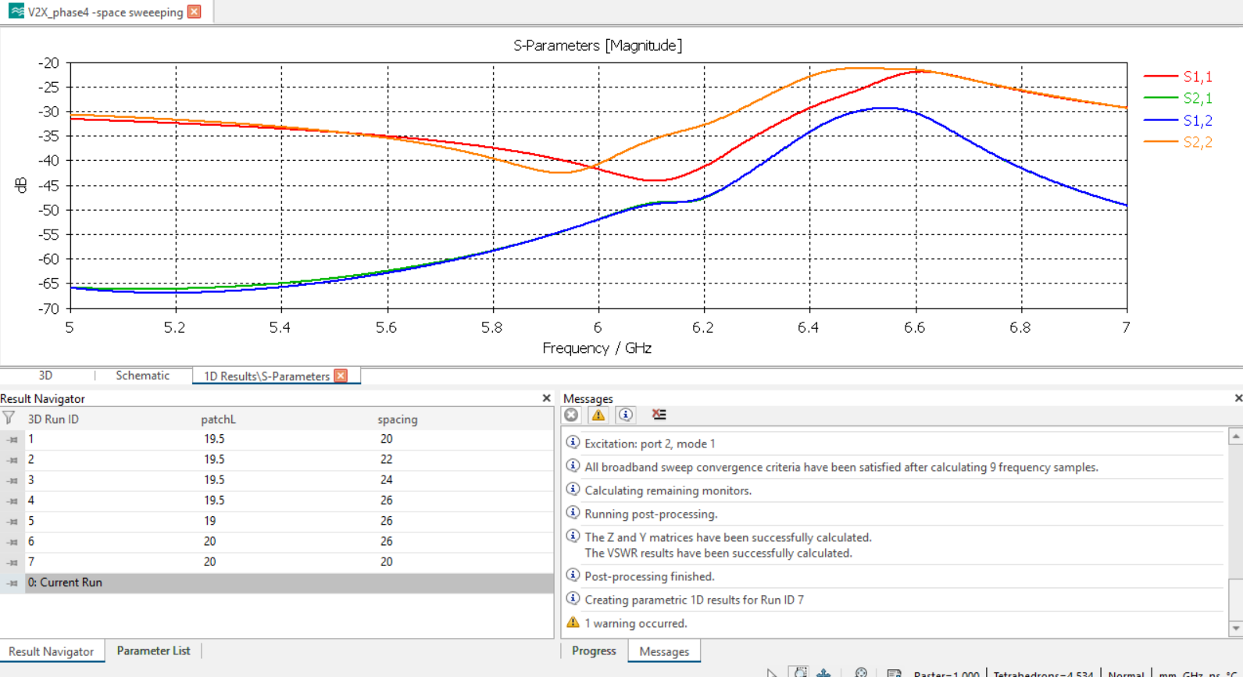

7.2 VSWR Analysis
The Voltage Standing Wave Ratio (VSWR) was used to evaluate matching quality. The obtained VSWR values were close to unity for both ports, indicating minimal reflected power and efficient energy transfer from the feed network to the radiating elements.

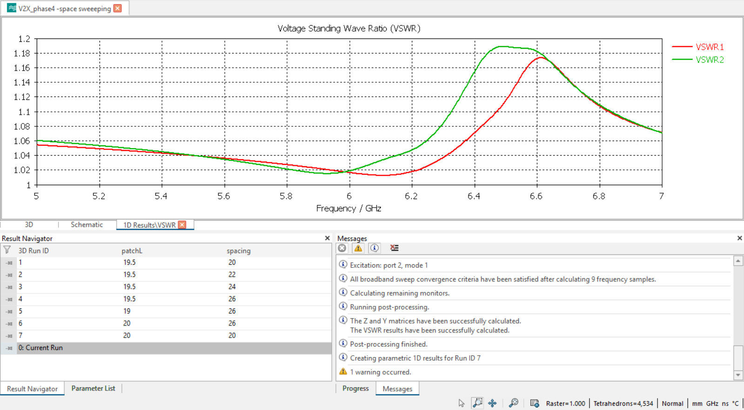

7.3 Isolation Performance
Isolation between antenna elements is an important parameter in MIMO systems. The optimized antenna achieved isolation better than -48 dB, which is significantly lower than the commonly accepted threshold of -15 dB. This result confirms minimal electromagnetic interaction between antenna elements.

7.4 Envelope Correlation Coefficient (ECC)
The Envelope Correlation Coefficient was calculated using the simulated S-parameters. The obtained ECC value was approximately 10⁻⁵, indicating extremely low correlation between antenna elements. Such a low ECC value confirms excellent diversity performance and suitability for MIMO communication systems.

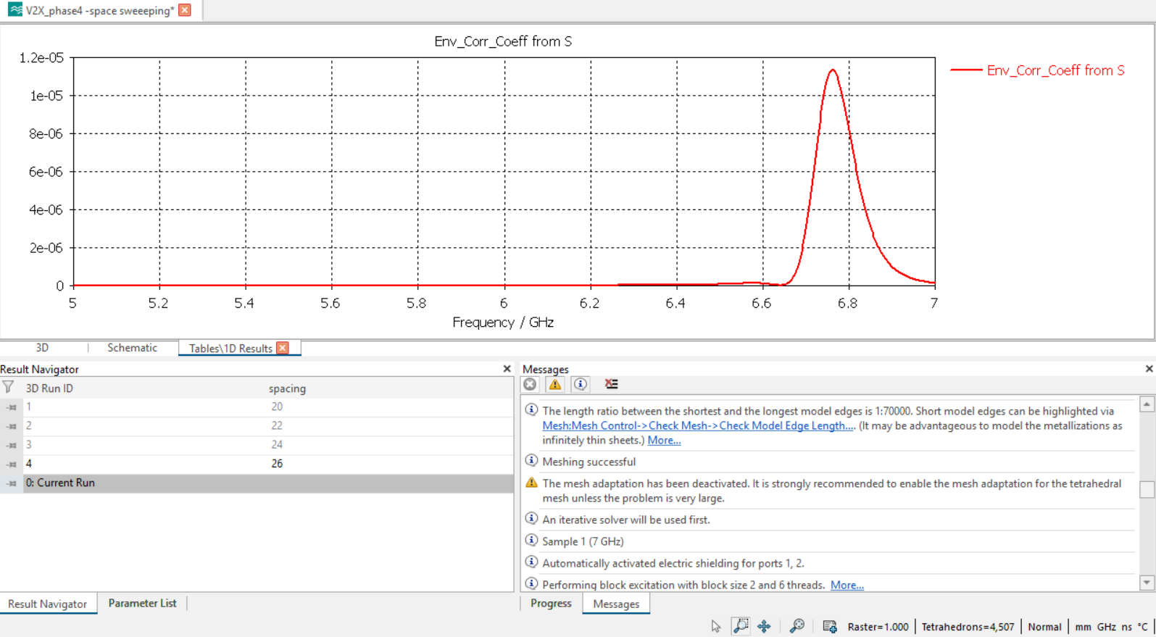

7.5 Radiation Characteristics
Far-field analysis showed directional radiation patterns suitable for V2X communication applications. The antenna achieved a directivity of approximately 4.85 dBi at the operating frequency. The radiation pattern exhibited stable characteristics with acceptable beamwidth and side-lobe levels.

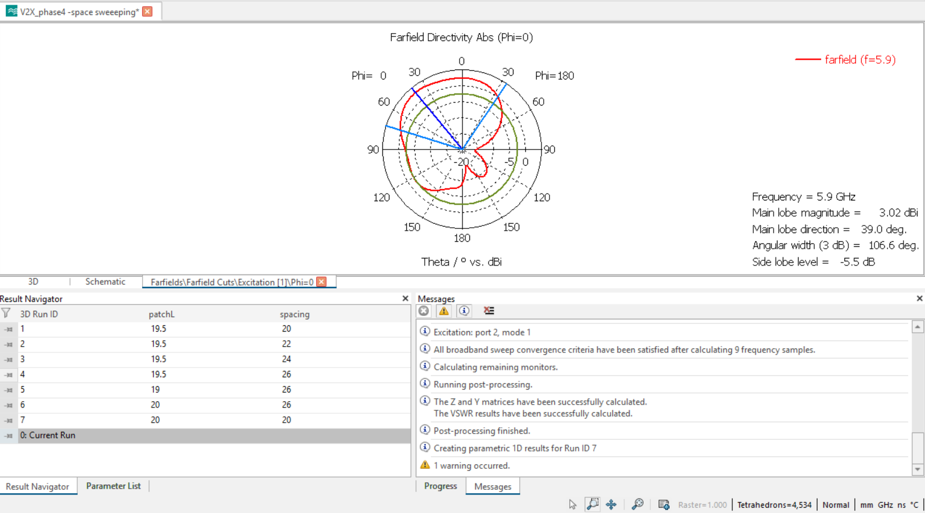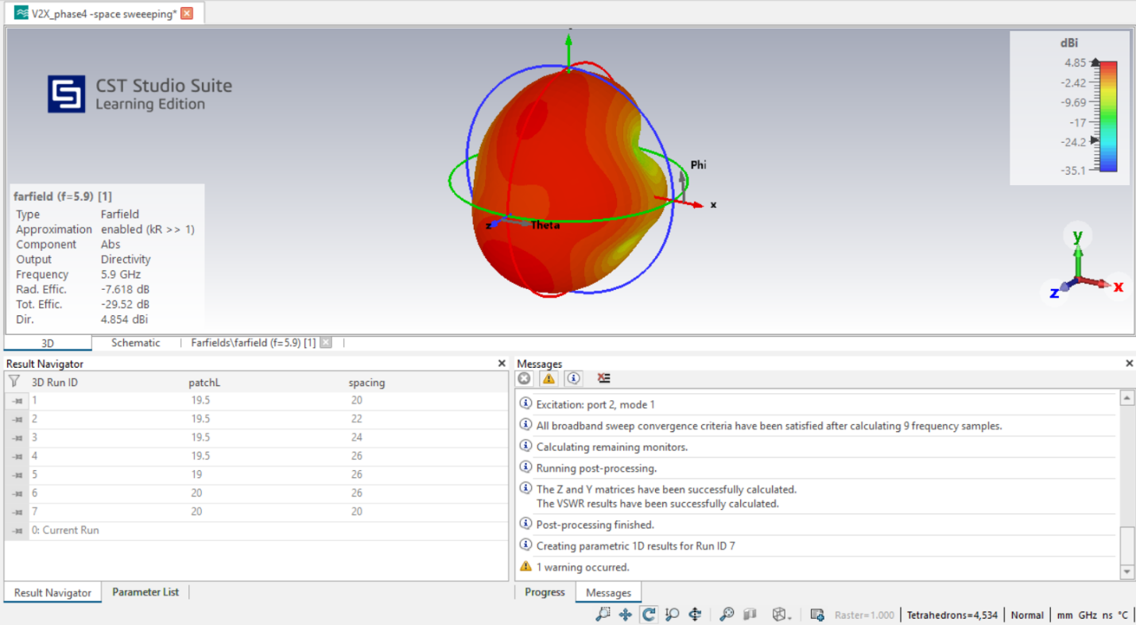

7.6 Efficiency Analysis
Radiation efficiency and total efficiency were evaluated using CST simulation results. The antenna demonstrated acceptable radiation behavior; however, efficiency values indicate potential scope for future improvement through substrate selection, feed optimization, or advanced antenna enhancement techniques.

7.7 Discussion
The simulation results confirm that the proposed two-element MIMO microstrip patch antenna satisfies the primary requirements of V2X communication systems. The antenna provides excellent impedance matching, very high isolation, low ECC, and near-ideal Diversity Gain. Parametric optimization successfully identified the optimum antenna dimensions and spacing required to achieve the desired performance. The proposed design therefore represents a compact and effective solution for 5.9 GHz vehicular communication applications.

8. Advantages
The proposed two-element MIMO microstrip patch antenna offers several advantages for V2X communication applications.
• Compact and low-profile antenna structure.
• Simple geometry resulting in easy fabrication and implementation.
• Excellent impedance matching at the operating frequency.
• Very low VSWR indicating efficient power transfer.
• High isolation between antenna elements.
• Extremely low Envelope Correlation Coefficient (ECC).
• Diversity Gain close to the ideal value of 10 dB.
• Suitable for integration into vehicular communication systems.
• Low-cost substrate material and simple feed structure.
• Capability to support MIMO communication techniques for improved reliability and channel capacity.

10. Limitations
Although the proposed antenna demonstrates satisfactory performance, several limitations exist.
• The antenna performance has been evaluated only through simulation.
• No physical fabrication or experimental validation has been performed.
• FR-4 substrate introduces dielectric losses at higher frequencies.
• Radiation efficiency remains lower than ideal values and may require further optimization.
• The antenna is designed for a single operating frequency band.
• Environmental effects such as temperature variations and installation conditions have not been considered.
• Vehicle body integration effects have not been investigated.
Despite these limitations, the antenna provides a suitable foundation for further development and experimental implementation.

11. Future Scope
The proposed antenna can be further improved and extended in several directions.
• Fabrication and experimental testing using a Vector Network Analyzer (VNA).
• Investigation of alternative substrate materials such as Rogers RT/duroid for improved efficiency.
• Development of multi-band V2X antennas supporting additional wireless standards.
• Implementation of circular polarization to improve communication reliability.
• Integration of Electromagnetic Band Gap (EBG) structures for enhanced isolation.
• Application of artificial intelligence and optimization algorithms for automated antenna design.
• Design of larger MIMO arrays to achieve higher gain and improved channel capacity.
• Investigation of reconfigurable and beam-steering antenna techniques for future intelligent transportation systems.
These improvements can further enhance antenna performance and expand its applicability in next-generation vehicular communication networks.

12. Conclusion
A two-element MIMO microstrip patch antenna operating at 5.9 GHz for Vehicle-to-Everything (V2X) communication applications has been successfully designed and analyzed using CST Studio Suite. The antenna was developed on an FR-4 substrate and optimized through extensive parametric studies involving patch dimensions, feed structure, and inter-element spacing.
The simulation results demonstrated excellent impedance matching with return loss values below -40 dB and VSWR values close to unity. High isolation between antenna elements was achieved, resulting in very low mutual coupling and enhanced MIMO performance. The antenna exhibited an Envelope Correlation Coefficient in the order of 10⁻⁵ and a Diversity Gain close to 10 dB, confirming excellent diversity characteristics.
The influence of antenna spacing and patch dimensions was investigated through parameter sweeps, and an optimized configuration was obtained. A Defected Ground Structure was also evaluated; however, the baseline antenna already exhibited excellent performance, making additional ground modifications unnecessary.
Overall, the proposed antenna satisfies the primary requirements of V2X communication systems and demonstrates the effectiveness of MIMO technology in improving wireless communication reliability. The obtained results indicate that the antenna can serve as a promising candidate for future vehicular communication applications.

13. References
- C. A. Balanis, Antenna Theory: Analysis and Design, 4th Edition, Wiley, 2016.
- R. Garg et al., Microstrip Antenna Design Handbook, Artech House.
- D. M. Pozar, Microwave Engineering, 4th Edition.
- IEEE papers on V2X communication systems.
- IEEE papers on MIMO microstrip antennas.
- IEEE papers on Defected Ground Structures (DGS).
- CST Studio Suite Documentation.
- 3GPP/ETSI documentation for V2X communication.

